
WHAT TIME IS IT?
This Photo by Unknown Author is licensed under CC BY-SA-NC

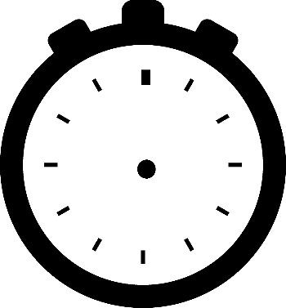
If in Pakistan is 1 a.m.

What time is in :

United Kingdom (5 hours backwards) Australii ( 5 hours forward)
Spain ( 4 hours backwards) Brazil - Rio de Janeiro (7 hours backwards)
If in Pakistan is 3 a.m.
What time is in :
Poland (4 hours backwards) Egypt (3 hours backwards)

Kenya ( 2 hours backwards) Canada – Toronto ( 10 hours backwards)

Marocco ( 4 hours backwards) Philippines ( 3 hours forward)
If in China is 7 a.m.
What time is in :
Pakistan (3 hours backwards) Japan ( 1 hour forward )

Peru ( 13 hours backwards) Zimbabwe ( 6 hours backwards)

New Zealand ( 5 hours forward ) Germany ( 7 hours backwards)

If in Argentina – Buenos Aires is 10 a.m.
What time is in :
Pakistan (8 hours forward) Finland ( 5 hours forward)

Kuwait ( 6 hours forward) South Africa ( 5 hours forward )
Switzerland ( 4 hours forward ) South Korea ( 12 hours forward)

If in Germany is 1 a.m.
What time is in :
Pakistan (4 hours forward) Norway ( 0 hours difference)

Etiopii ( 2 hours forward ) Cuba (6 hours backwards)
Russia - Moscow ( 2 hours forward) USA – Chicago ( 7 hours backwards)

